EUROPEAN PUT

MAIN MATRIX
S₀ = 100 | Time = 1 | Sigma = 0.02 | Lamda = 1.22474 | Risk free = 0.05
Number of iterations | CRR | KR | DiffCRR | DiffKR
 |  | K = 90 | BS = 2,3101
5 | 2,1697 | 2,2649 | 0,1404 | 0,0452
10 | 2,3328 | 2,3610 | -0,0227 | -0,0509
20 | 2,3113 | 2,3050 | -0,0012 | 0,0051
40 | 2,3359 | 2,3208 | -0,0258 | -0,0107
60 | 2,2925 | 2,3181 | 0,0176 | -0,0080
80 | 2,3226 | 2,3117 | -0,0125 | -0,0016
100 | 2,3211 | 2,3145 | -0,0110 | -0,0044
 |  | K = 100 | BS = 5,5735
5 | 5,9289 | 5,4719 | -0,3554 | 0,1016
10 | 5,3764 | 5,5202 | 0,1972 | 0,0534
20 | 5,4742 | 5,5464 | 0,0993 | 0,0271
40 | 5,5237 | 5,5598 | 0,0498 | 0,0137
60 | 5,5403 | 5,5644 | 0,0333 | 0,0091
80 | 5,5486 | 5,5667 | 0,0250 | 0,0069
100 | 5,5536 | 5,5680 | 0,0200 | 0,0055
 |  | K = 110 | BS = 10,6753
5 | 10,2871 | 10,6542 | 0,3883 | 0,0211
10 | 10,7344 | 10,6999 | -0,0591 | -0,0245
20 | 10,6015 | 10,6932 | 0,0739 | -0,0178
40 | 10,7141 | 10,6923 | -0,0388 | -0,0169
60 | 10,6699 | 10,6634 | 0,0054 | 0,0119
80 | 10,6674 | 10,6839 | 0,0079 | -0,0085
100 | 10,6885 | 10,6732 | -0,0131 | 0,0022

PLOTS (DIFFERENT LAMDA)

AT THE MONEY
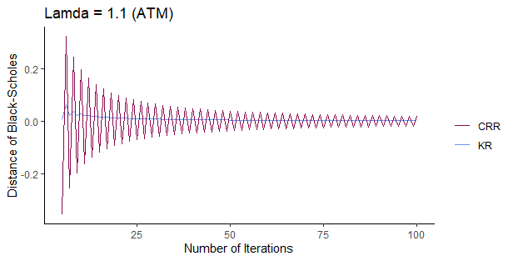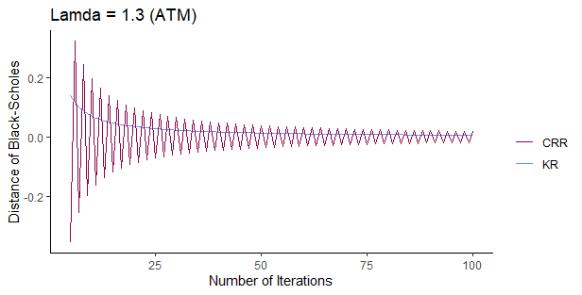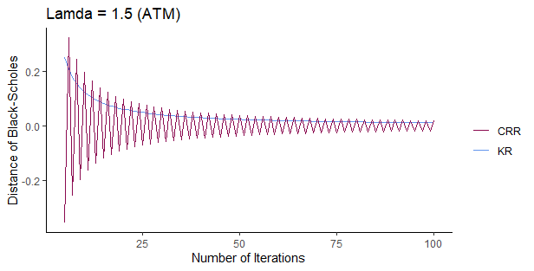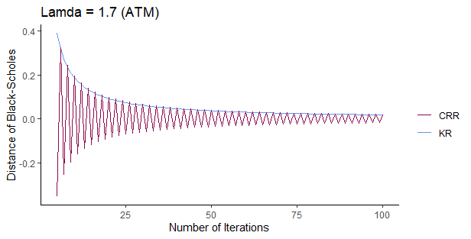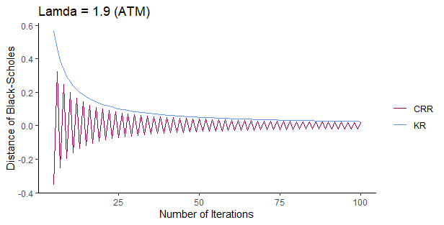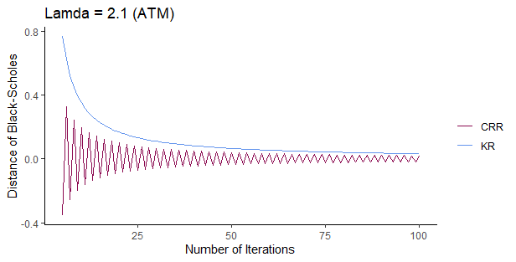

IN THE MONEY
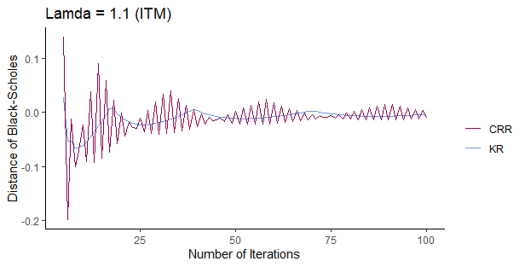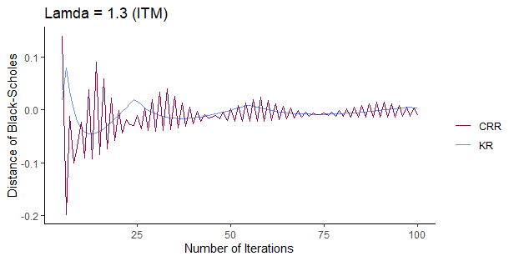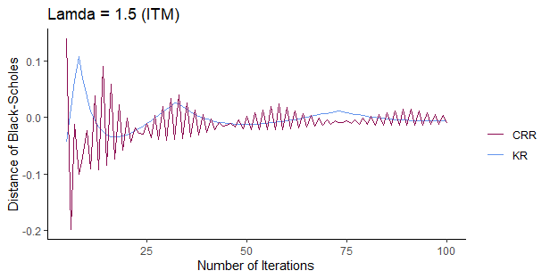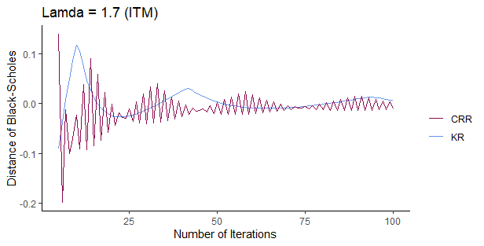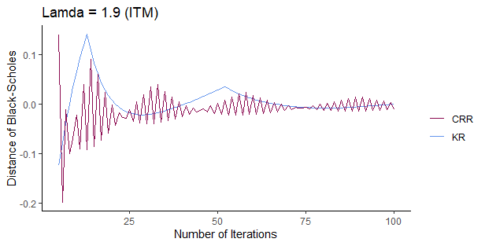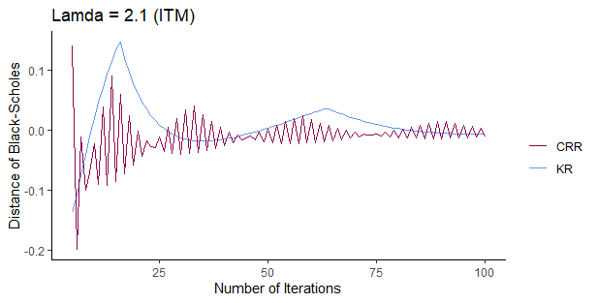

OUT THE MONEY

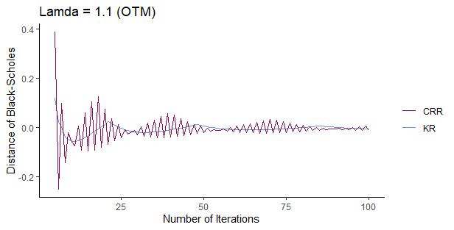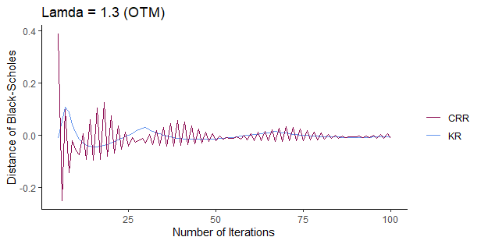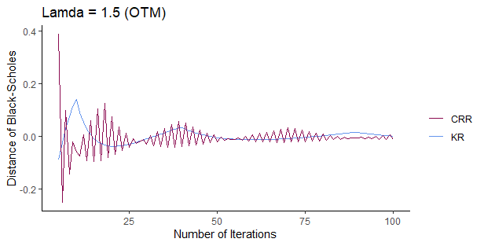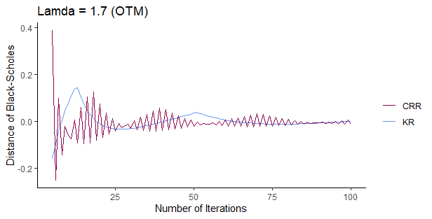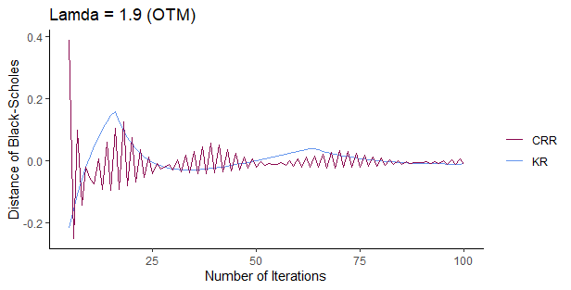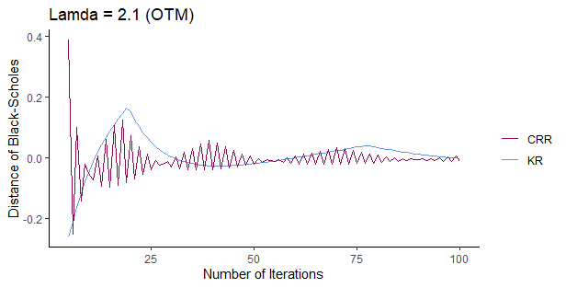

VOLATILITY ANALYSIS

S₀ = 100 | K = 100 | Risk Free = 0.05 | Lamda = 1.22474 | Time = 1
Number of iterations | CRR | KR | DiffCRR | DiffKR
 |  | Sigma = 0.15 | BS = 3,7146
5 | 3,9610 | 3,6259 | -0,2464 | 0,0887
10 | 3,5636 | 3,6686 | 0,1510 | 0,0460
20 | 3,6385 | 3,6913 | 0,0761 | 0,0233
40 | 3,6764 | 3,7029 | 0,0382 | 0,0117
60 | 3,6891 | 3,7068 | 0,0255 | 0,0078
80 | 3,6955 | 3,7087 | 0,0191 | 0,0059
100 | 3,6993 | 3,7099 | 0,0153 | 0,0047
 |  | Sigma = 0.18 | BS = 4,8253
5 | 5,1379 | 4,7295 | -0,3126 | 0,0958
10 | 4,6466 | 4,7752 | 0,1786 | 0,0501
20 | 4,7353 | 4,7998 | 0,0900 | 0,0255
40 | 4,7801 | 4,8125 | 0,0452 | 0,0128
60 | 4,7952 | 4,8167 | 0,0301 | 0,0086
80 | 4,8027 | 4,8188 | 0,0226 | 0,0064
100 | 4,8072 | 4,8201 | 0,0181 | 0,0052
 |  | Sigma = 0.24 | BS = 7,0807
5 | 7,5191 | 6,9655 | -0,4383 | 0,1152
10 | 6,8463 | 7,0200 | 0,2344 | 0,0608
20 | 6,9626 | 7,0498 | 0,1181 | 0,0310
40 | 7,0215 | 7,0651 | 0,0592 | 0,0156
60 | 7,0412 | 7,0703 | 0,0395 | 0,0104
80 | 7,0511 | 7,0729 | 0,0297 | 0,0078
100 | 7,0570 | 7,0744 | 0,0237 | 0,0063

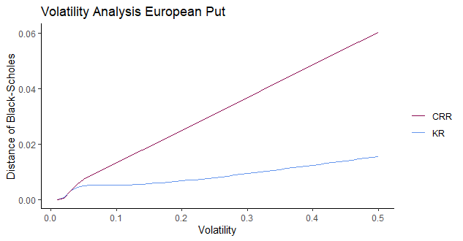

RISK FREE ANALYSIS
S₀ = 100 | K = 100 | Sigma = 0.02 | Lamda = 1.22474 | Time = 1
Number of iterations | CRR | KR | DiffCRR | DiffKR
 |  | Risk free = 0.01 | BS = 7,4383
5 | 7,8377 | 7,3476 | -0,3994 | 0,0907
10 | 7,2427 | 7,3901 | 0,1956 | 0,0482
20 | 7,3398 | 7,4137 | 0,0985 | 0,0246
40 | 7,3889 | 7,4259 | 0,0494 | 0,0124
60 | 7,4053 | 7,4300 | 0,0330 | 0,0083
80 | 7,4135 | 7,4321 | 0,0248 | 0,0062
100 | 7,4185 | 7,4333 | 0,0198 | 0,0050
 |  | Risk free = 0.04 | BS = 6,0040
5 | 6,3746 | 5,9073 | -0,3706 | 0,0967
10 | 5,8078 | 5,9530 | 0,1962 | 0,0510
20 | 5,9052 | 5,9780 | 0,0988 | 0,0260
40 | 5,9544 | 5,9909 | 0,0496 | 0,0131
60 | 5,9709 | 5,9952 | 0,0331 | 0,0088
80 | 5,9792 | 5,9974 | 0,0248 | 0,0066
100 | 5,9841 | 5,9987 | 0,0199 | 0,0053
 |  | Risk free = 0.07 | BS = 4,7809
5 | 5,0984 | 4,6651 | -0,3175 | 0,1157
10 | 4,5807 | 4,7208 | 0,2001 | 0,0601
20 | 4,6801 | 4,7504 | 0,1008 | 0,0304
40 | 4,7303 | 4,7655 | 0,0506 | 0,0153
60 | 4,7471 | 4,7706 | 0,0338 | 0,0102
80 | 4,7555 | 4,7732 | 0,0253 | 0,0077
100 | 4,7606 | 4,7747 | 0,0203 | 0,0062

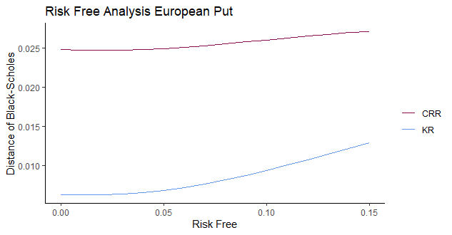

TIME ANALYSIS
S₀ = 100 | K = 100 | Sigma = 0.02 | Lamda = 1.22474 | Risk free = 0.05
Number of iterations | CRR | KR | DiffCRR | DiffKR
 |  | Time = 2/12 | BS = 2,8449
5 | 3,0072 | 2,8071 | -0,1623 | 0,0378
10 | 2,7645 | 2,8248 | 0,0804 | 0,0200
20 | 2,8044 | 2,8346 | 0,0405 | 0,0102
40 | 2,8246 | 2,8397 | 0,0203 | 0,0052
60 | 2,8313 | 2,8414 | 0,0136 | 0,0035
80 | 2,8347 | 2,8423 | 0,0102 | 0,0026
100 | 2,8367 | 2,8428 | 0,0081 | 0,0021
 |  | Time = 5/12 | BS = 4,1289
5 | 4,3771 | 4,0671 | -0,2482 | 0,0618
10 | 4,0017 | 4,0962 | 0,1272 | 0,0327
20 | 4,0648 | 4,1122 | 0,0641 | 0,0167
40 | 4,0968 | 4,1205 | 0,0321 | 0,0084
60 | 4,1074 | 4,1233 | 0,0214 | 0,0056
80 | 4,1128 | 4,1247 | 0,0161 | 0,0042
100 | 4,1160 | 4,1255 | 0,0129 | 0,0034
 |  | Time = 8/12 | BS = 4,8942
5 | 5,1978 | 4,8137 | -0,3036 | 0,0804
10 | 4,7333 | 4,8518 | 0,1609 | 0,0424
20 | 4,8131 | 4,8726 | 0,0811 | 0,0216
40 | 4,8535 | 4,8833 | 0,0407 | 0,0109
60 | 4,8670 | 4,8869 | 0,0271 | 0,0073
80 | 4,8738 | 4,8887 | 0,0204 | 0,0055
100 | 4,8779 | 4,8898 | 0,0163 | 0,0044

